Name: Anuj Parihar  
Reg No: 21BBS0162  
Course: Programming in Python CBS1011

Q1 i. Write a Python program(i)To create a tuple with numbers and print all elements.

Code:

# Name: Anuj Parihar

# RegNo: 21BBS0162

tup = (1, 2, 3, 4, 5)

for i in tup:

    print(i)

Output:

ii. To add an element “hello” to the tuple.

Code:

# Name: Anuj Parihar

# RegNo: 21BBS0162

tup = (1, 2, 3, 4, 5)

tup = tup + ('hello',)

print(tup)

Output:

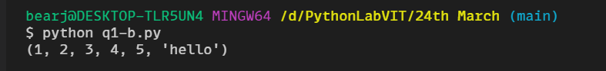

Q2. Write a program calculate the product(multiplying all the numbers of a given tuple).  
Input: (4, 3, 2, 2, -1, 18)  
Output: -864

Code:

# Name: Anuj Parihar

# RegNo: 21BBS0162

tup = tuple(map(int, input().split()))

f = 1

for i in tup:

    f = f*i

print(f)

Output:

Q3 Write a program to calculate the average value of the numbers in a given tuple of tuples.  
Input: ((10, 10, 10, 12), (30, 45, 56, 45), (81, 80, 39, 32), (1, 2, 3, 4))  
Output: [30.5, 34.25, 27.0, 23.25]

Code:

# Name: Anuj Parihar

# RegNo: 21BBS0162

tup = ((1, 2, 3, 4, 5), (5,6,7,8,9), (11, 12, 13, 14, 15))

l = []

for i in tup:

    sum = 0

    for j in i:

        sum = sum + j

    l.append(sum/len(i))

print(l)

Output:  
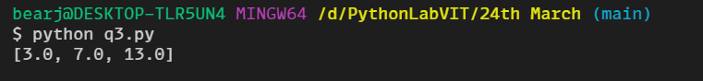

Q4. Write a Python program to replace last value of tuples in a list.  
Input: [(10, 20, 40), (40, 50, 60), (70, 80, 90)]  
Output: [(10, 20, 100), (40, 50, 100), (70, 80, 100)]

Code:

# Name: Anuj Parihar

# RegNo: 21BBS0162

l = [(1, 2, 3), (4, 5, 6), (7, 8, 9)]

for i in range(len(l)):

    l[i] = l[i][:-1] + (100,)

print (l)

Output:

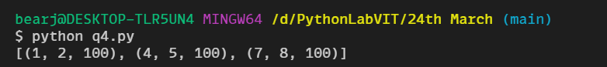

Q5. Write a Python program to compute the sum of all the elements of each tuple stored inside a list of tuples.  
Input: [(1, 2), (2, 3), (3, 4)]  
Output: [3, 5, 7]

Code:

# Name: Anuj Parihar

# RegNo: 21BBS0162

li = [(1, 2, 3), (4, 5, 6), (7, 8, 9)]

sumOftup = []

for i in range(len(li)):

    sum = 0

    for j in range(len(li[i])):

        sum = sum + li[i][j]

    sumOftup.append(sum)

print(sumOftup)

Output:

